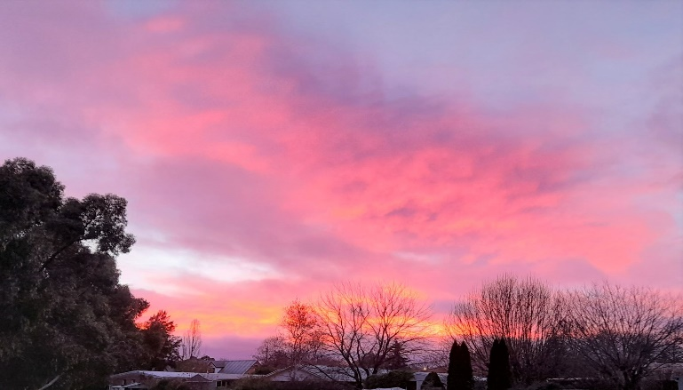
Winter Camp in Orange
25 and 26 June 2022

Program

Saturday 25th June
11am | Brunch at Café Latte | For anyone coming the night before or travelling early on Saturday  (café is in same building as Dojo)
12noon | Registration Desk Opens | Dojo is in Uniting Church Hall,  217 Anson St Orange
1pm to 5.30pm | Aikido Training | Warm-up +  2 sessions of 2 hours each  (format TBC on day)
From 6pm | Drinks at Lord Anson  followed by Dinner | Connect with your billet or  ‘check into’ your accommodation;  partners and family welcome for  drinks and dinner
After Dinner | It’s Up to You | Ice Cream at Spilt Milk or  Whiskey and other delights at  Washington & Co … if you’re keen

Sunday 26th June
9am to 12.15pm | Aikido Training | Warm-up +  2 sessions of 1.5 hours each  (format TBC on day)
From 12.30pm | Lunch and Farewells | Lunch Provided
After … | Wine Tasting /  Sight Seeing | We can give you recommendations!

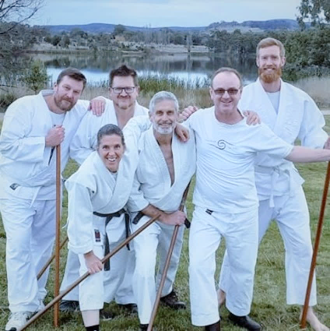
Contact

So, that’s the plan for the weekend – hope you like it!

If you have any questions, just give us a call:
Paddy on 0409 711 494 or Fiona on 0474 549 654

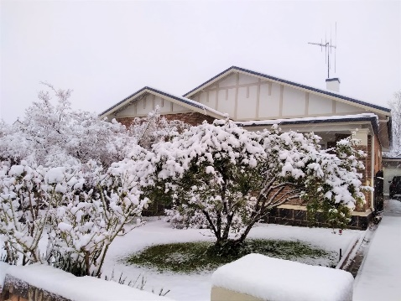
Accommodation
There are a limited number of billeting options available. And of course there’s a wide range of motels, hotels and caravan parks. Try these suggestions:
High end: De Russie Suites or Byng Street Boutique Hotel
Central: The Mid City Motor Lodge or Central Caleula Motor Lodge
Budget: Colour City Caravan Park

Registration Form
(Please complete and return by Sunday 19th June at latest)
Name
Address or Email
Phone Number
Home Dojo

Event and Cost | Attendance | When to Pay | Please Enter Amount Paying in Advance
Full weekend’s training $80 | Yes | In advance
If not training for full weekend, please indicate which day:  Saturday $45  Sunday $45 | Saturday  Sunday | In advance
Saturday evening dinner | No. of Adults _____  No. of Children _____ | On night | NA
Sunday lunch | Yes  No | Included in camp fee | NA
Total Amount Payable
Date of Bank Transfer | Account Name: Aikido Kenkyukai Orange  BSB: 802318 Account No: 40005906 |  | ____/____/_____
* Please note any dietary requirements: _______________________________________________________

